

Recruitment task

Test tasks for Java Script developers

Author: Magnis

Created: 11/04/2019

Classification: Confidential

Document version: 1.0.0

**Task Description:**

Сreate the landing page

**This landing page should be:**

* Adaptive from 1920px to 320px using the Bootstrap 3 framework
* Cross browsers (Chrome/FireFox/IE10+/Safari/android/IOS)
* Can not be used inline style or !important

**Home-block**

At the top of the site there are mobile images that should swiped automatically and with each other, as in this example, <https://codepen.io/shamim539/pen/vdaqQG>

Рlease use Swiper.js library

**Funfact-block**

1. 1. For a block background, you need to use Parallax Scrolling Effect with the image that is in PSD Mockup.
2. 2. For numbers in the block apply a counter, which will quickly count from 0 to the number specified in the mockup for each value (Coffee cups, subscribers, etc.). It is important that the counter begins to count only when the user sees this block.

**Just download it**

When scrolling on this unit, the image of the laptop should smoothly appear on the right side.

**Responsive:**

**CTA «CONTACT US»**

**Call-to-action (CTA) buttons are the buttons you use in your website and on your landing pages to guide users towards your goal conversion.**

Starting from size container: 768px; The block with the form should be placed not from the bottom of the page, but after the block

* Home-block. You also need to add CTA. It is a floating "sticky" button, which will scroll the user to a block with a form when pressed.

If user encounters a form on the site's crawl, then this CTA must also disappear, so that there is no double-clicking on the page.

**The button should look like this:**

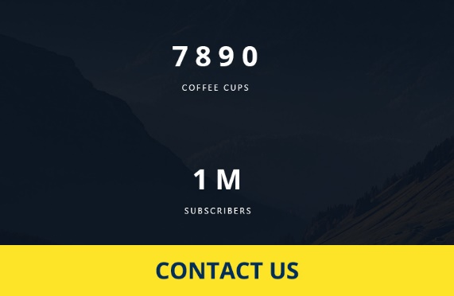

* The names of the blocks coincide with the names of the layers that are in the PSD Mockup

** All icons should be in svg format

**Download to the git repository (we recommend github) and upload to the some hosting (we recommend https://gist.github.com/TylerFisher/6127328) necessary steps are from 4 to 8**

**Maximum time for completing the task: 3 days.**